Exercise 5

- List all employees who hold the titles pf “Senior Programmer” and “MultiMedia Programmer”.
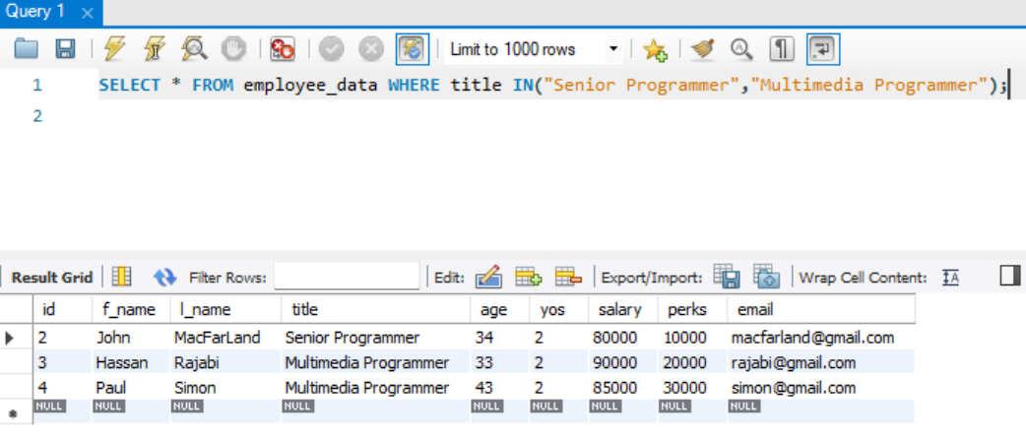
- List all employee names with salaries for employees who draw between $7000) ad 90000.
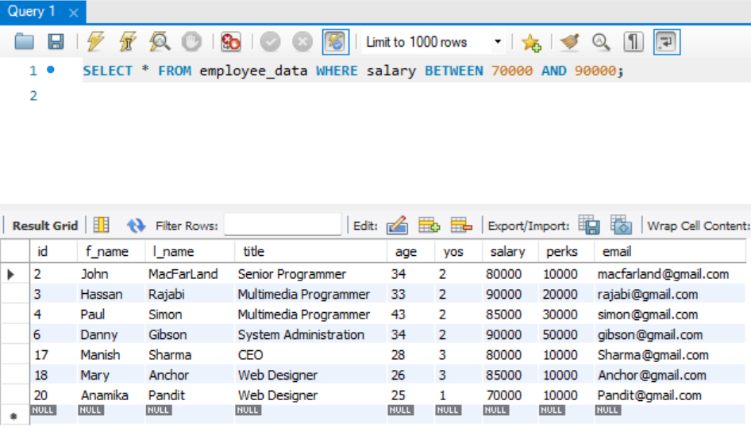
- What will the following statement display?
SELECT f_name, l_name, title from employee_data where title NOT IN (‘Programmer’, ‘Senior Programmer’, Multimedia Programmer’);

Returns the first name, last name and title of all the employees that does not have the title on the IN statement

- Here is a more complex statement that combines both BETWEEN and IN. What will it display?
SELECT f_name, l_name, title, age from employee_data where title NOT IN (‘Programmer’, ‘Senior Programmer’, Multimedia Programmer’) AND age NOT BETWEEN 28 and 32;

Returns the first name, last name, title and age of all the employees that does not have the title on the IN statement and age outside the range of 28 to 32

